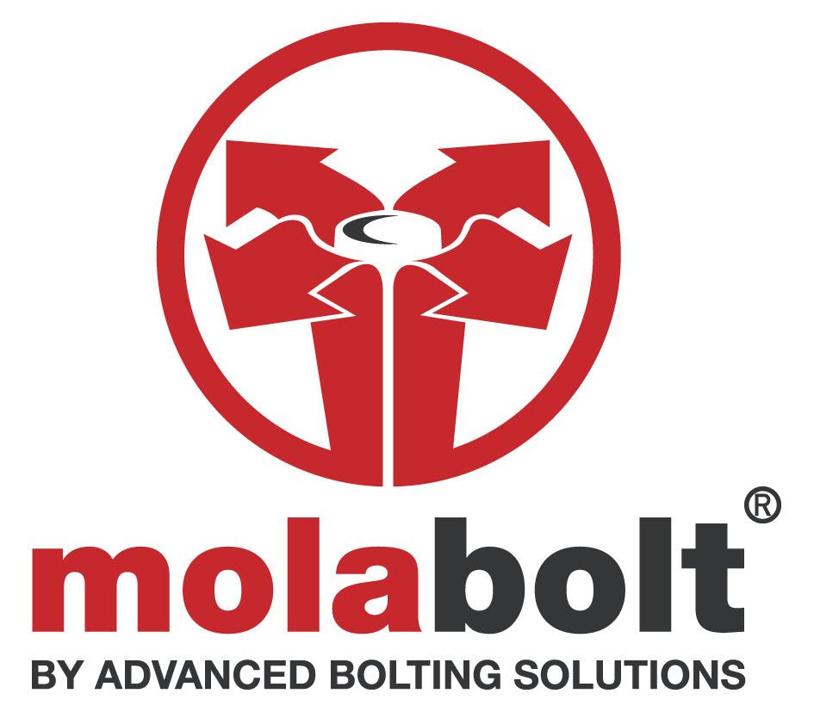

GUIDANCE NOTE #2 – pre-load torque settings (PEG ANCHOR)

1. INTRODUCTION

This guidance note provides details on recommended torque settings for specified diameter dimensions.

2. RECOMMENDED PRE-LOAD TORQUE SETTINGS

Bolt Diameter Torque Load

M8 20 NM

M10 35 NM

M12 50NM

M14 75NM

M16 100NM

M20 125 NM

M22 150 NM

M24 175 NM

3. GENERAL

For items with a non-stock diameter, please contact our sales department for further advice on (0116) 251 2251.

